Q No. 7 – Write a inline CSS code to depict background colour and headings.
<!DOCTYPE html>
<html>
<head>
<title>Inline CSS</title>
</head>

<body style="background-color: lightblue;">

<h1 style="color: red; background-color: yellow;">
This is Heading 1
</h1>

<h2 style="color: blue; background-color: pink;">
This is Heading 2
</h2>

</body>
</html>
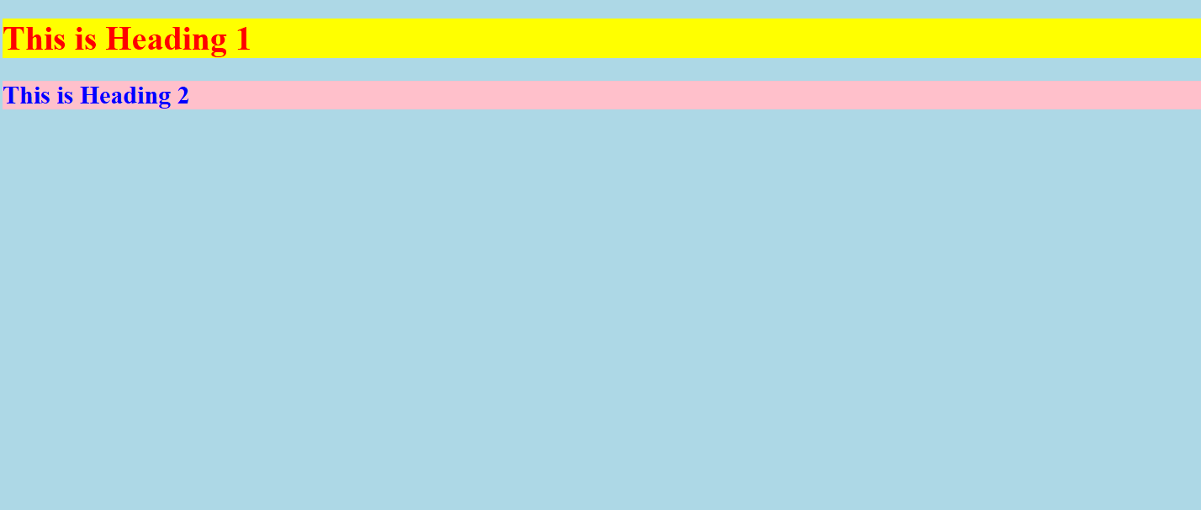

Q No.7- Write a Internal CSS code to depict background colour and headings.
<!DOCTYPE html>
<html>
<head>
<title>Internal CSS</title>

<style>
body {
background-color: lightgreen;
}

h1 {
color: red;
background-color: yellow;
}

h2 {
color: blue;
background-color: pink;
}
</style>
</head>

<body>

<h1>This is Heading 1</h1>
<h2>This is Heading 2</h2>

</body>
</html>
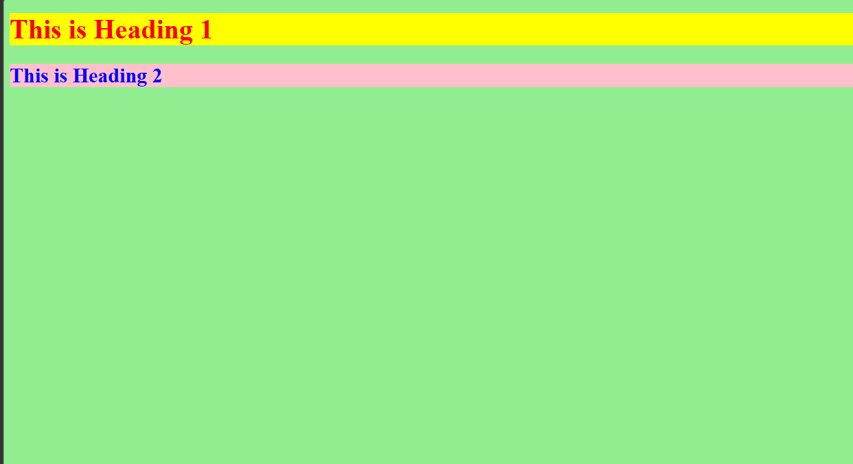

Q No. 7 Write a External CSS to depict background colour and headings.
<!DOCTYPE html>
<html>
<head>
<title>External CSS</title>

<link rel="stylesheet" href="style.css">
</head>

<body>

<h1>This is Heading 1</h1>
<h2>This is Heading 2</h2>

</body>
</html>


